QUALITY LABEL:

Short description (max. 150 words) *
Please provide a short summary/description of your project (1 paragraph).
“Why Maths Matters” is a project that deals with mathematics – applications and connections with real life. By working on the project, the students tried to find the answer to a famous question ‘When am I ever going to use this?’ Why do people go to the gym to ride the stationary bike? It's not so that they can compete in the stationary bike Olympics, it’s to build up their endurance and strength to make the rest of their lives easier and more enjoyable. Maths is like a gym for the brain. One may never need to use the quadratic equation in their adult life, but the process of learning it boosts their brainpower. By practicing how to solve mathematical problems, people optimize their ability to make complex decisions down the road. And while students cannot possibly practice every problem they will ever have in life, studying maths can help them learn how to think logically.

Links to Project Outcomes
Please include all links to any online outcomes of your project such as a website, public TwinSpace, audio/video clips, etc.
https://padlet.com/biljana_pipovic71/h9rb05qckeyf
https://padlet.com/monika_orz1/f24pif0oo5ys
https://twinspace.etwinning.net/44423/forums/forum/41684/topic/466413
https://twinspace.etwinning.net/44423/forums/forum/41684/topic/466414
https://padlet.com/biljana_pipovic71/uugx09ftu04e
https://padlet.com/monika_orz1/c0ln6uouyjd5
https://twinspace.etwinning.net/44423/forums/forum/43242/topic/475175
https://twinspace.etwinning.net/44423/forums/forum/43242/topic/480215
https://padlet.com/biljana_pipovic71/yqr7yod0a1ar
https://padlet.com/biljana_pipovic71/zwwddqg09usg
https://padlet.com/biljana_pipovic71/8vblstbfvren
https://padlet.com/biljana_pipovic71/pfxa888t15vp
https://twinspace.etwinning.net/44423/forums/forum/46262/topic/500788
https://twinspace.etwinning.net/44423/forums/forum/46262/topic/500794
https://twinspace.etwinning.net/44423/forums/forum/46262/topic/500806
https://twinspace.etwinning.net/44423/forums/forum/46262/topic/500812
https://padlet.com/biljana_pipovic71/8nl3t8xnfrkg
https://padlet.com/monika_orz1/9wt5v7l5qfzx
https://www.facebook.com/pg/english.club.vlasotince.srb/photos/?tab=album&album_id=1693850460654426
https://twinspace.etwinning.net/44423/pages/page/390449
https://twinspace.etwinning.net/44423/pages/page/392091
Other documents
Please upload any other documents not available online such as texts, presentations, audio/video clips, etc.
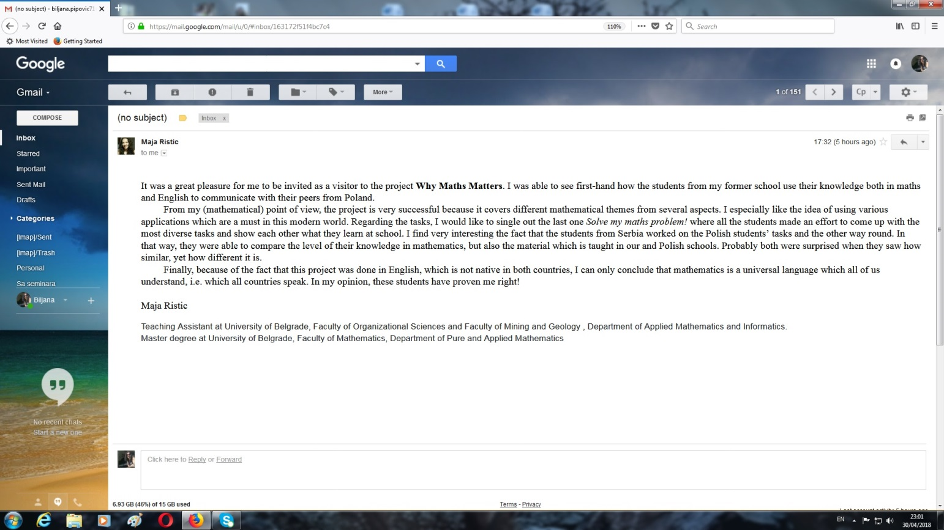
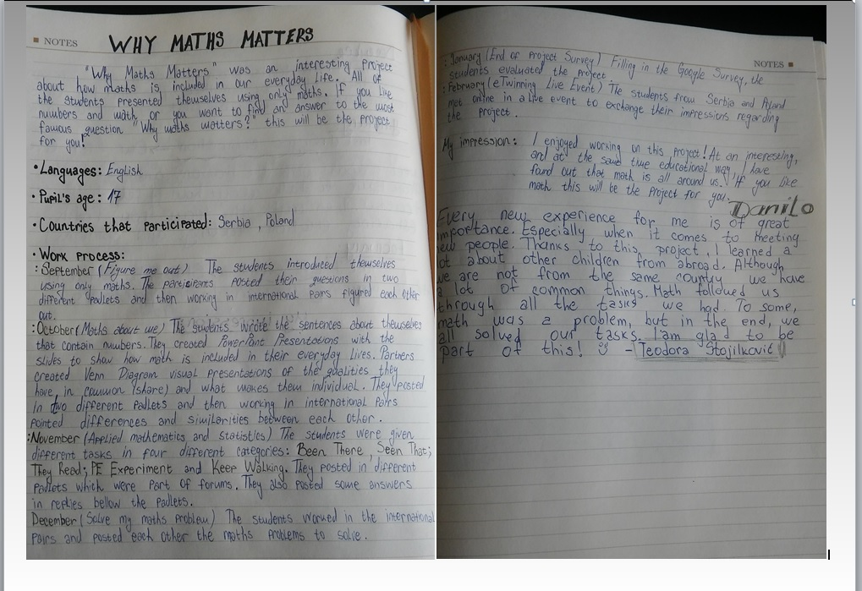
Pedagogical Innovation and Creativity (max. 2000 characters) *
Please provide a description of your project (1 paragraph).
Please describe the various pedagogical methods you have used with your pupils during the project work. (Examples; small group work, independent research by pupils, etc.) If your pupils are very young, please describe the methods you used to engage their interest in the project.
The project aimed at raising students' awareness of the importance of maths in real life. By doing different activities, the students were constantly motivated to look for maths everywhere around them. Although they attend the Science-Mathematics course, they had never had a chance to do maths in English so what we did in class (regarding maths) was highly motivational and stimulating. The project also aimed to develop problem solving skills, enhance key life skills, including ICT and communicative skills using English as the means of global communication. Most of the work regarding the project topic took place in the regular classes and all the students were involved. Some of the project tasks were assigned for homework and the outcomes were presented both in the class and in TwinSpace. The students worked both in and outside of the classroom individually and in international pairs (new pairs were matched for every task). Even though the project consisted of only four tasks, each task meant and included different activities so the students needed more time to complete them. The aim of the first two tasks was to enable the students to get to know each other, while the goals of the other two were to make them use maths while solving real life problems. CLIL (content and language integrated learning) turned out to be a very good approach for this particular project. Mathematics was inserted into all sorts of topics – even within the not so obvious ones such as toys. I even assigned a peer teacher to help the students look at the topic from a different perspective. The peer teacher was instructed to prepare the lesson plan that will connect the topics which have been covered - sports and maths knowledge and she completed the task in an amazing way combining an association game (with the sports terminology) and different maths tasks. I monitored her work when it comes to the use of language while the maths teacher was consulted regarding the maths tasks. The class the peer teacher held was huge success!
Curricular integration (max. 2000 characters) *
Please describe (in steps) how you tried to integrate the project into your existing curriculum.
What competencies did you try to develop in your pupils during the project work?
Describe how the pupils worked on the project
The project is the part of my curriculum. It goes with the course book English in Mind 4 (CUP) that we use in the third grade. Since this project was done by the students who attend the Science-Mathematics course, I tried to integrate maths into my lesson plans whenever it was possible. It started with the individual presentations (the activities Figure me out and Maths about me), then the students started using Venn diagram: first to find similarities and differences between each other and then to compare and contrast different things (such as chess and boxing or The Ancient and The Modern Olympic Games). When we talked about sport, the students had to answer the question Where does mathematics appear in sports? They had to identify shapes when describing toys and do a drawing dictation when practicing personality adjectives.
The aim of the project was in the first place to develop communication in English as the foreign language - the students expanded their vocabulary regarding mathematical terms and scientific terminology. Apart from developing communication in foreign language, the aim of the project was to develop mathematical competence as well as basic competence in science and technology - a set of competencies that are fundamental to the development of ‘mathematical literacy’, or a person’s ability to apply their mathematical knowledge to practical situations. And last, but not least, working on the project the students also developed their digital competence as they had to create PowerPoint presentations, post on the padlets and interact with each other using Forums; and as the highlight of the project took part in the Live event.
Communication and exchange between partner schools (max. 200 words) *
How did you organise the communication between you and your partners?
What communication activities did you design for or with your pupils for sharing the work of each class on the themes of the project?
Communication among teachers was taking place through email and Teacher bulletin on TwinSpace. The teachers discussed every step of the project in details making sure everything runs smoothly and that the students follow the instructions and finish their task within the given time limits and the space provided for it.
The students communicated in Forums, during the Live event and on social networks (mostly Instagram).
The project activities were discussed on regular basis by the school principal, who is a Mathematics teacher and the class Mathematics teacher. Being experts in their field, they contributed with their professional guidance and clarification when needed.
I discussed the theme of the project with the former student and present Mathematics professor and Teaching Assistant at University of Belgrade, Faculty of Organizational Sciences and Faculty of Mining and Geology, Department of Applied Mathematics and Informatics, Ms Maja Ristic. She visited our TwinSpace and expressed her immense satisfaction with the themes of the project and talked about it with her colleagues at University. Their positive feedback regarding project activities motivated the students even more and boosted their confidence.
Collaboration between partner schools. (max. 200 words) *
Collaboration activities go beyond communication. Please describe the work process of the project clearly outlining the division of work between you and your partner(s). Most importantly:
In what aspects of the project did you and your partner(s) collaborate?
In what activities did pupils collaborate and work together?
Describe how the final products of the project were achieved by the pupils
Both students and teachers started and completed the project with the same enthusiasm. The project consisted of four activities which were educational and required a lot of thinking and introspection. The teachers had a perfect collaboration and mutual understanding. The project tasks were clearly defined and project deadlines determined in advance. Using Teacher bulletin mostly, the teachers carefully discussed every step of the project, respecting and taking into account each other’s opinion. The students were encouraged to actively communicate with their partners in all activities. The teachers in turn matched the students in pairs, so by the end of the project they had a chance to directly collaborate with at least four different students from a partner country. First, the students got to know each other in an amusing yet highly educational way. They posted their questions on two different padlets and then working in international pairs figured each other out. The discussion took place in Forums. Second, the students wrote the sentences about themselves that contain numbers. They created PowerPoint Presentations with the slides to show how math is included in their everyday lives. Partners created Venn Diagram visual presentations of the qualities they have in common (share) and what makes them individual. They posted on two different padlets and then working in international pairs pointed differences and similarities between each other. The discussion took place in Forums. Third, the students were given different tasks in four different categories. They posted on different padlets which were part of forums. The also posted some answers in replies bellow the padlets. For the last activity, the students worked in the international pairs and posted each other the maths problems to solve. Finally, the Live Event was the highlight of the project as the students saw each other and were able to match the names (and biographies) and the faces. They presented their opinion, but also asked and answered questions. The most important part of interaction was that they were using English as a common language to exchange ideas, knowledge and interests.

Use of technology (max. 200 words) *
Please describe how technology has been used to further the work of the project both by your partners and you, and by the pupils
The teachers used email to communicate with each other as well as Teacher Bulletin.
In order to complete the tasks assigned, the students used Padlets to post their presentations or problems and talked to each other writing in Forums. In order to complete certain tasks, the students had to post their photos, so they used Screenshot, Paint and Adobe Photoshop to prepare them. To prepare the presentations, the students used Microsoft PowerPoint Online. They also used Microsoft Excel and Easel.ly to design Venn Diagrams.
In order to evaluate the project, the online Google Survey is created. The students also filled in the Mentimeter.
Finally, there was the online meeting which was organized using eTwining Live.
It is important to emphasize that the Serbian students had never worked on the eTwinning platform before but were more than willing to explore. Finding the appropriate tool and designing the infographics and diagrams was both challenging and motivational for them. They were really proud of the final outcome.
Results, impact and documentation (max. 200 words) *
What impact do you think this project has had upon your pupils and your work as a teacher?
How did your school benefit from participating in this project?
What do you regard as the most successful result of this project?
Have you given links to all the documentation relating to the planning, progress and outcomes of the project?
Throughout the project, whether working in class or working in TwinSpace, the students were made to think about what knowing maths can mean for their future careers as employers recognize that if you can do math, you can do any job that calls for precise analysis and careful deduction. What is more, the knowledge of maths especially if accompanied by the higher level of English competence can open many doors and lead to multitude of interesting and rewarding jobs.
Some benefits of this project according to the survey conducted at the end of the project: foreign language competence (58.8% absolutely agree that working on the project helped them improve their English, while 29.4% state their English improved especially regarding mathematical vocabulary; 56.3% absolutely agree that working on the project improved their self-confidence when it comes to using English); increased motivation for studying (76.5% agree with the statement that the way they got to know each other and exchanged knowledge was motivational).
Thanks to this project, I got to know my students much better regarding their interests and opinions. Personally, I was in a position to brush up my Maths knowledge and ensure my students understand that English and Maths are two universal languages every one understands.

